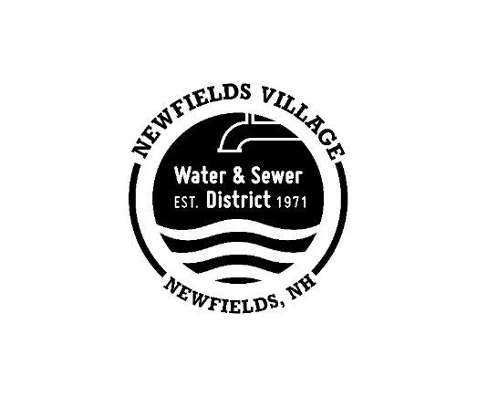

Newfields Village Water & Sewer District
75 Main Street, P.O. Box 301
Newfields, NH 03856-0301
603-772-1058

The Newfields Village Water & Sewer Department will hold a public hearing on Thursday, June 20, 2024 at 5:00PM to discuss the following:
To hold a procedural defect meeting on July 1, 2024 in accordance with provisions of RSA 31:5-b. To ratify the results of the April 22, 2024 annual meeting even though the posting requirements were not met.
Newfields Village Water & Sewer District Commissioners

Posted 6/5/2024
Posted in newspaper 6/8/2024

